Packet Tracer – Access Control List Demonstration

1. Topology

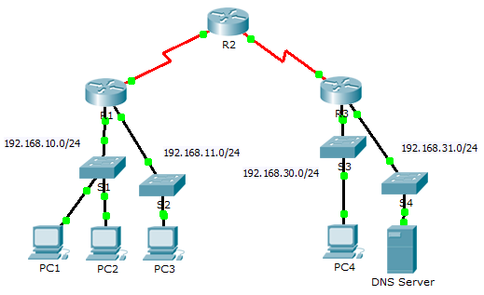

1. Objectives

Part 1: Verify Local Connectivity and Test Access Control List

Part 2: Remove Access Control List and Repeat Test

1. Background

In this activity, you will observe how an access control list (ACL) can be used to prevent a ping from reaching hosts on remote networks. After removing the ACL from the configuration, the pings will be successful.

1. Verify Local Connectivity and Test Access Control List
   1. Ping devices on the local network to verify connectivity.
      1. From the command prompt of **PC1**, ping **PC2**.
      2. From the command prompt of **PC1**, ping **PC3**.

Why were the pings successful? _________________________________________________________

____________________________________________________________________________________

* 1. Ping devices on remote networks to test ACL functionality.
     1. From the command prompt of **PC1**, ping **PC4**.
     2. From the command prompt of **PC1**, ping the **DNS Server**.

Why did the pings fail? (Hint: Use simulation mode or view the router configurations to investigate.)

____________________________________________________________________________________

1. Remove ACL and Repeat Test
   1. Use show commands to investigate the ACL configuration.
      1. Use the **show run** and **show access-lists** commands to view the currently configured ACLs. To quickly view the current ACLs, use **show access-lists**. Enter the **show access-lists** command, followed by a space and a question mark (?) to view the available options:

R1#**show access-lists ?**

<1-199> ACL number

WORD ACL name

<cr>

If you know the ACL number or name, you can filter the **show** output further. However, **R1** only has one ACL; therefore, the **show access-lists** command will suffice.

R1#**show access-lists**

Extended IP access list 101

deny icmp any any echo

permit ip any any

The first line of the ACL prevents Internet Control Message Protocol (ICMP) echos (ping requests) from **any** source to **any** destination. The second line of the ACL allows all other **ip** traffic from **any** source to **any** destination.

* + 1. For an ACL to impact router operation, it must be applied somewhere. In this scenario, the ACL is used to filter traffic on an interface. Although you can view IP information with the **show ip interface** command, it may be more efficient in some situations to simply use the **show run** command. Using one or both of these commands, to which interface is the ACL applied to? _________________
  1. Remove access list 101 from the configuration

You can remove ACLs from the configuration by issuing the **no access list** [*number of the ACL*] command. The **no access-list** command deletes all ACLs configured on the router; the **no access-list** [*number of the ACL*] command removes only a specific ACL.

* + 1. In global configuration mode, remove the ACL by entering the following command:

R1(config)# **no access-list 101**

* + 1. Verify that **PC1** can now ping the **DNS Server**.

1. Suggested Scoring Rubric

|  |  |  |
| --- | --- | --- |
| Question Location | Possible Points | Earned Points |
| Part 1, Step 1 b. | 50 |  |
| Part 1, Step 2 b. | 40 |  |
| Part 2, Step 2 b. | 10 |  |
| **Total Score** | **100** |  |